

Royal Observatory Belgium

Functional Design Document

[Digisun NextGen]

[15/04/2015]

Contents

[[Digisun NextGen] 1](#_Toc431375730)

[Contents 2](#_Toc431375731)

[Document History 4](#_Toc431375732)

[Publication 4](#_Toc431375733)

[References 4](#_Toc431375734)

[Introduction 5](#_Toc431375735)

[Scope 5](#_Toc431375736)

[Definitions 5](#_Toc431375737)

[Figures 6](#_Toc431375738)

[Overview Functional Requirements 7](#_Toc431375739)

[Prerequisites 7](#_Toc431375740)

[Pillars for development 8](#_Toc431375741)

[Functional Requirements 9](#_Toc431375742)

[Workflows 9](#_Toc431375743)

[Digisun workflow 10](#_Toc431375744)

[Login at start of the application 15](#_Toc431375745)

[Usage of statuses indicating progress 15](#_Toc431375746)

[Calibration before Analysis 17](#_Toc431375747)

[Other changes 17](#_Toc431375748)

[Scanning of drawings 17](#_Toc431375749)

[Analysis of drawings (and images) 18](#_Toc431375750)

[Calibration 18](#_Toc431375751)

[Analysis 18](#_Toc431375752)

[Drawing Status 19](#_Toc431375753)

[Saving information to database 19](#_Toc431375754)

[Export to various formats 20](#_Toc431375755)

[From Digisun to Digisun NextGen 20](#_Toc431375756)

[Data Structures 20](#_Toc431375757)

[Database as-is 20](#_Toc431375758)

[Database to-be 24](#_Toc431375759)

[User Interface 29](#_Toc431375760)

[The menu bar 30](#_Toc431375761)

[The icon bar 30](#_Toc431375762)

[The control section 30](#_Toc431375763)

[Calibration section 30](#_Toc431375764)

[Analysis section 31](#_Toc431375765)

[Drawing section 31](#_Toc431375766)

[The working section 32](#_Toc431375767)

[Groups section 32](#_Toc431375768)

[Image section 33](#_Toc431375769)

[The status bar 34](#_Toc431375770)

[Configuration 35](#_Toc431375771)

[Risks / Issues 35](#_Toc431375772)

[Security 36](#_Toc431375773)

[Performance 36](#_Toc431375774)

[Constraints and limitations 36](#_Toc431375775)

[Appendix 37](#_Toc431375776)

[Appendix A: Q & A 37](#_Toc431375777)

[Appendix B: Trains of thought 37](#_Toc431375778)

[Appendix C: Types of drawings 38](#_Toc431375779)

[Type: USET 38](#_Toc431375780)

[Type: USET41 39](#_Toc431375781)

[Type: USET77 39](#_Toc431375782)

Document History

|  |  |  |  |  |
| --- | --- | --- | --- | --- |
| Name | Type | Description | Date | Version |
| Vincent Malisse | creation | Document setup and outline | 15/04/2015 | V0.1 |
| Vincent Malisse | Update | Update to document Started workflow diagrams | 08/06/2015 | V0.2 |
| Vincent Malisse | Update | Added database table definitions | 10/08/2015 | V0.3 |
| Vincent Malisse | Update | Added chapters Risks/Issues, Security, Performance and Constraints and Limitations.  Several changes throughout the document. | 02/09/2015 | V0.4 |
| Vincent Malisse | Update | Document check, small changes. | 07/09/2015 | V0.5 |
| Vincent Malisse | Update | Added tables for allowing users to “save” surface calculation work. | 11/09/2015 | V0.6 |
| Vincent Malisse Olivier Lemaitre | Final version before publication | Removed placeholders. Clarified open questions | 30/09/2015 | **V1.0** |
|  |  |  |  |  |

Publication

This document is for ORB/ROB personnel only.

References

|  |  |  |
| --- | --- | --- |
| Reference | Description | Version |
| Workflow.vsd | Document containing the workflow diagrams | / |
| Database.vsd | Document containing database table defintions | / |
| UI Mockup (folder) | A mockup of the UI. | / |

Introduction

Scope

This document will describe all required functionality for the new version of Digisun.

To avoid confusion the name of the new version of Digisun (or at least the project of rewriting the old version) should be distinguishable.

Some propositions:

* Digisun NextGen
* Digisun 2.0
* Digisun++
* Digisun Web
* SunAnalyzer

In this document Digisun NextGen will be used, the definitive name should be chosen BEFORE development starts.

Definitions

|  |  |
| --- | --- |
| Term | Description |
| ASCII | American Standard Code for Information Interchange  (<https://en.wikipedia.org/wiki/ASCII>) |
| DPI | Dots Per Inch |
| FITS | Flexible Image Transport System  (<https://en.wikipedia.org/wiki/FITS>) |
| ISES | International Space Environment Service (<http://www.spaceweather.org/>) |
| JPG | Or JPEG, Joint Photographic Experts Group  (<https://en.wikipedia.org/wiki/JPEG>) |
| PNG | Portable Network Graphics (<https://en.wikipedia.org/wiki/Portable_Network_Graphics>) |
| (G)UI | (Graphical) User Interface  (<https://en.wikipedia.org/wiki/Graphical_user_interface>) |
| USET | Uccle Solar Equatorial Table  (<http://sidc.oma.be/uset/>) |
| USSPS | Ursigram SunSPotS  (<http://www.spaceweather.org/ISES/code/od/ussps.html>) |
|  |  |

Figures

|  |  |
| --- | --- |
| Id | Description |
| [Figure 1](#Figure_1) | The basic workflow of the current Digisun application. |
| [Figure 2](#Figure_2) | Drill down of the calibration and analyze processes of the basic workflow of the current Digisun application. |
| [Figure 3](#Figure_3) | Digisun NextGen workflow |
| [Figure C1](#Figure_C1) | Drawing type USET |
| [Figure C2](#Figure_C2) | Drawing type USET41 |
| [Figure C3](#Figure_C3) | Drawing type USET77 |
| [Figure 4](#Figure_4) | UI mockup – screenshot |
| [Figure 5](#Figure_5) | The menu bar |
| [Figure 6](#Figure_6) | The icon bar |
| [Figure 7](#Figure_7) | Control section – Calibration |
| [Figure 8](#Figure_8) | Control section – Analysis |
| [Figure 9](#Figure_9) | Control section – Drawing |
| [Figure 10](#Figure_10) | Working section – Groups |
| [Figure 11](#Figure_11) | Working section – Image |

Overview Functional Requirements

Following is a high level list of functionality required for Digisun NextGen.

In the paragraph “Functional Requirements” each of the following items will be discussed in detail.

* Workflows
* Scanning of drawings
* Analysis of drawings (and images)
* Saving information to database
* Export to various formats
* From Digisun to Digisun NextGen
* Data Structures
* User Interface
* Configuration
* Risks/Issues
* Security
* Performance
* Constraints and limitations

Prerequisites

* Client
  + Internet connection
  + Internet Explorer, Firefox, Safari or Chrome
* Server
  + Sufficient hardware
    - Processing power
    - Memory
    - Disk space
* Database

|  |
| --- |
| **Note:** Client and Server can potentially be the same machine. Data storage could also be another machine, but will not be discussed. |

Pillars for development

Following are the pillars (maximum 5) to which development of the Digisun NextGen should comply.

These are keywords for developers to help them in the application logic.

1. **Usability**This pillar indicates that the application at all-time should be easy to use and follow intuitive user actions. Some examples:
   1. The user should always know where to find actions, how the workflow of the application works and what he should do (and what the application does).
   2. The user should not have to do actions or execute workflows that are difficult and/or time consuming.
   3. The user will be able to work with a responsive UI.

**Keywords:** avoid too many clicks, the user knows when and where the data is saved, guidance text where necessary, good and logical user design using text, color and icons where appropriate.

1. **Accessibility**

This pillar indicates the accessibility of the application for users.

* 1. The application will also be available outside ROB for all (ROB?) users.

|  |
| --- |
| **Note:** This question has not been answered, but is not important for describing the functionality. However, this should be answered before development starts. It is still an open question in Appendix A: Q&A |

* 1. The application can be easily ported to other institutes.

Functional Requirements

Workflows

See next page. First the current workflow is discussed, then the new workflow.

Digisun workflow

  
**Figure 1: Current Digisun workflow**

Basically, in the current digisun, there are three different workflows :

1. **Daily Scan**This feature is used daily to scan and analyze a single drawing just made. It is used the most often. Basic flaws here include the saving mechanism and the possibly loss of calibration when forgetting to save.
2. **Bulk Scan**This feature is used to scan in multiple drawings one after the other. It does not allow calibration or analysis. It can also be used to rescan an existing image.
3. **Bulk Analyze**This feature is used to analyze multiple drawings (after they were alsready scanned and added to the database). This feature also allows Surface Calculation (currently only in DEV) of sunspot groups.

  
**Figure 2: Zoom-in on the Calibration and Analyze processes.**

Calibration is done by clicking 2 points. For USET and USET41 drawing types this is the center and the north of the solar disc. For USET77 drawing types this is the south and the north of the solar disc.

Analysis is done by defining the features of the sunspot groups on the solar disc. The location is saved by clicking on the group’s estimated center. The number of spots, Zurichs - and McIntosh classifications are defined. In case the Zurich classification implies a dipole, the dipole direction can be defined. A helper grid is available to help distinguish between different group classifications.

In addition, in Bulk analyze only at this time, the surface of the sunspot group can be determined. This is done by switching this feature “on” (press the button)and following the “wizard” to prepare the drawing with the necessary parameters. Then a polyline can be drawn to determine the area that includes the sunspot group. A popup allows the user to “fix” any scan errors, missing penumbras, … When all sunspot groups are calculated the wizard can be exited and the data written back to the original screen. The user must press save to save the values to database.

**Figure 3: Digisun NextGen Workflow**

There are several distinctive differences in this workflow compared to the current Digisun workflow.

1. Login at start of the application.
2. Usage of statuses indicating progress.
3. Calibration before Analysis
4. Other changes

Login at start of the application

The login will be more thorough (username/password) and 100% unique. This will allow a user to clearly identify the person who made the analysis of a drawing. It will also prevent a non-user to modify the data willingly or unwillingly. Not logging in, still makes the application usable, but only in a read-only mode. When a web-based tool is preferred, the login remains active until the end of the session or if the application is closed. Logging out is also always possible. This feature will also allow saving the history on drawings, indicating who worked on it and when. Keeping the changes per user will become too complex.

Usage of statuses indicating progress

There are three types of statuses.

1. Calibration status
2. Analysis status
3. Overall status

Each of these types has following status options

1. New
2. Work In Progress
3. To Review
4. Finished

These statuses are at all times visible for a drawing and are indicated by colors and icons.

The colors are:

* New = blue (#FF3333FF),
* work in progress = orange (#FFFF6600),
* to review = purple (#FF6600AA),
* finished = green (#FF009933).

The icon set is the following:

Calibration

D:\Work\Projects\uset_repos\uset_repos_nextgen\2.FA\Icons\1.Globe_48.pngD:\Work\Projects\uset_repos\uset_repos_nextgen\2.FA\Icons\1.Globe_48I.pngD:\Work\Projects\uset_repos\uset_repos_nextgen\2.FA\Icons\2.Globe_48.pngD:\Work\Projects\uset_repos\uset_repos_nextgen\2.FA\Icons\2.Globe_48I.pngD:\Work\Projects\uset_repos\uset_repos_nextgen\2.FA\Icons\3.Globe_48.pngD:\Work\Projects\uset_repos\uset_repos_nextgen\2.FA\Icons\3.Globe_48I.pngD:\Work\Projects\uset_repos\uset_repos_nextgen\2.FA\Icons\4.Globe_48.pngD:\Work\Projects\uset_repos\uset_repos_nextgen\2.FA\Icons\4.Globe_48I.png

Analysis

D:\Work\Projects\uset_repos\uset_repos_nextgen\2.FA\Icons\1.Instrument Telescope_48.pngD:\Work\Projects\uset_repos\uset_repos_nextgen\2.FA\Icons\1.Instrument Telescope_48I.pngD:\Work\Projects\uset_repos\uset_repos_nextgen\2.FA\Icons\2.Instrument Telescope_48.pngD:\Work\Projects\uset_repos\uset_repos_nextgen\2.FA\Icons\2.Instrument Telescope_48I.pngD:\Work\Projects\uset_repos\uset_repos_nextgen\2.FA\Icons\3.Instrument Telescope_48.pngD:\Work\Projects\uset_repos\uset_repos_nextgen\2.FA\Icons\3.Instrument Telescope_48I.pngD:\Work\Projects\uset_repos\uset_repos_nextgen\2.FA\Icons\4.Instrument Telescope_48.pngD:\Work\Projects\uset_repos\uset_repos_nextgen\2.FA\Icons\4.Instrument Telescope_48I.png

Overall

D:\Work\Projects\uset_repos\uset_repos_nextgen\2.FA\Icons\1.File Ok_48.pngD:\Work\Projects\uset_repos\uset_repos_nextgen\2.FA\Icons\1.File Ok_48I.pngD:\Work\Projects\uset_repos\uset_repos_nextgen\2.FA\Icons\2.File Ok_48.pngD:\Work\Projects\uset_repos\uset_repos_nextgen\2.FA\Icons\2.File Ok_48I.pngD:\Work\Projects\uset_repos\uset_repos_nextgen\2.FA\Icons\3.File Ok_48.pngD:\Work\Projects\uset_repos\uset_repos_nextgen\2.FA\Icons\3.File Ok_48I.pngD:\Work\Projects\uset_repos\uset_repos_nextgen\2.FA\Icons\4.File Ok_48.pngD:\Work\Projects\uset_repos\uset_repos_nextgen\2.FA\Icons\4.File Ok_48I.png

Possible status combinations are:

|  |  |  |
| --- | --- | --- |
| **Calibration status** | **Analysis status** | **Overall status** |
| new | new | new |
| work in progress | new | work in progress |
| finished | new | work in progress |
| finished | work in progress | work in progress |
| finished | to review | to review |
| finished | finished | finished |
| to review | new | to review |
| to review | work in progress | to review |
| to review | to review | to review |
| to review | finished | to review |

Not possible are:

|  |  |
| --- | --- |
| new | work in progress |
| new | to review |
| new | finished |
| work in progress | work in progress |
| work in progress | to review |
| work in progress | finished |

The statuses will change as follows: “new” When nothing has been done for that type of progress, “work in progress” when something has been filled in and “finished”/”to review” is set manually. The overall status is set automatically. The “to review” status is a way for indicating the drawing has not been finished (and often there is some form of problem). The statuses allow a user to quickly see if work still needs to be done.

Note that a drawing status might be “summarized” in the bulk scan list eg. Indicating if the set still needs work. Clicking on the year, the month list can have an equal summary status.

Calibration before Analysis

In normal circumstances the calibration must be done before the analysis can start, with the exception for “to review”, but even in that case all “calibration data” must be present before continuing. In the case of a “rescan” the old data is still saved to database, but marked “invalid”. The old data is reused to fill in the new data, but the user will have to correct and/or verify the data in order to set the status back to “finished”.

Other changes

* Saving is done when the user clicks the “next” button.

Scanning of drawings

Digisun Nextgen should allow the user to scan a drawing from within the application. This might be a problem as some sort of interface needs to be foreseen to allow plugins, since other institutions do not have the same scanner. A necessary and easy workaround to avoid any failure on the plugin system is to allow users to scan images OUTSIDE Digisun NextGen and import them. Additionally, the application should allow for various image formats (jpg, bmp, tiff, png, …) and properties (dpi, image size, color table, compression, etc…)

Some sort of quality score is given to the image based on:

* Type of file (jpg, png, tiff, …)
* Scan resolution (dpi)
* Manual quality score (seeing quality, pencil thickness, …)
* (optional) scanner type
* (optional) Paper format

Analysis of drawings (and images)

Calibration

Today’s Digisun calibration consists of determining the center of the solar disc as well as its radius, by clicking on the center of the disc with the mouse and again on the north side of disc edge. This could result in somewhat inaccurate calibration when not done right or when the circle on the scan template was not exactly round.

Digisun NexGen could calibrate the image by placing a circle, possibly partly automatically detected, on top of the drawing and using that information for the calibration. In addition, this automated detection needs “cleaning” of the image which could also be used for further analysis of the drawing and could therefore be seen as an additional calibration. Indicating the north remains a mandatory step in the calibration process in order to gauge each drawing from an angular point of view (a drawing could be slightly misplaced on the scanner and therefore have a slight angle). This indication should also be shown as a small cross or dot in a different color so the user can always check where the North has been set. An overlay set “calibrations” could be added to the menu (cfr the current overlay menu) that will show all markers for the calibration (center, circle, north)

Practically this would mean that the calibration necessary for the surface calculation in the current situation is moved to the Calibration phase of the workflow.

All properties concerning calibration should be checked for validity.

Additionally, the user should give a quality score from 1-5 (poor quality – high quality)

Analysis

Analysis can only be done when the calibration has been done. This should be checked. Upon entering the analysis the user should enter the number of groups and this will create an empty user control for each group allowing the user to fill in the necessary data. By entering the number of groups, the application can more easily follow the status and adjust accordingly. Of course the number of groups value can be changed. Lowering the number of groups should be done by removing the corresponding group (which will automatically change the number). Increasing the group number will add empty groups at the end of the list.

Analysis consists of identifying the sunspot groups and assigning properties to them:

* McIntosh classification
  + Zurich class
  + p-values
  + c-values
* (Mount Wilson classifications?)
* Location
  + Coordinates
  + Quadrant
* Bipolar
* Surface
* Additional features ? (penumbras, … )

All sunspot properties should be easy to see and modifiable by the user and the user should be able to easily navigate between them. Visual aids are added to indicate what the user is working on (eg. Indication overlay for where the sunspot is on the drawing, what the “measured” area is, etc…

All properties concerning analysis should be checked for validity and regularly saved so the user can continue his/her work when closing and reopening the application. This includes the “cuts” when selecting a sunspot group for surface calculation, since these parts of the drawing are changed by “painting”.

|  |
| --- |
| **Note:** The cuts will receive the following filename: [drawingfilename]\_[sunspotgroupnumber].[extension] |

Drawing Status

This status is set to “new” when the drawing is added to the database. If the user is calibrating or analyzing this drawing the status is set to “work in progress”. When a user is unable to finish due to lack of time eg, this status is kept. If the user needs additional information (eg help from another observer) the status is set to “to review”. If the user is satisfied with the information he can “close” the drawing, preferably locking the data (which can be unlocked with a specific action or by a superuser eg.)

|  |
| --- |
| **Note:** The “to review” status implies that more than one user can work on drawings. Advice is to save ALL users that have worked on a drawing. |

Saving information to database

By definition all RAW information should be saved to database. Images can be stored on disc with the path saved in database. Possibly multiple image versions can co-exist (eg calibrated files and or masks next to the raw scanned image).

Any links between data is by use of primary/foreign keys and by use of a single sequence column. (no concatenated keys, no datetime stamps, no strings, …)

Export to various formats

A special export module will take care of generating any export needed. This could be ASCII reports in various formats (Leroy, USPPS, …) and with different extensions. This could be excel files or pdf reports or even images with overlays or a combination of all above. To be defined as the need arises. Immediate exports are Leroy and USSPS.

Another export to be done is towards other SIDC products (SIDC main page, previweb, …) and could possibly be through a web service, a data copy (from database to database) or through intermediary files.

From Digisun to Digisun NextGen

Some thought should be given to how the current data and functionality will be in Digisun NextGen. At minimum, a tool must be provided to port the data from one database structure to another.

Data Structures

Database as-is

The database on development: USET\_DEV is defined as follows:

|  |
| --- |
| **Note:**   * The record count is indicational * Tables marked with ‘\*’ are not used for digisun |

|  |  |  |  |  |
| --- | --- | --- | --- | --- |
| Name | Type | Primary Key | NOT NULL | Description |

|  |  |  |  |  |
| --- | --- | --- | --- | --- |
| Activities \* (12 records) | | |  |  |
| Id | INT(10) | X | X |  |
| DateTime | DATETIME |  |  |  |
| UserName | VARCHAR(255) |  |  |  |
| Action | TEXT |  |  |  |

|  |  |  |  |  |
| --- | --- | --- | --- | --- |
| Area \* (103 records) | | |  |  |
| Id | INT(10) | X | X |  |
| DateTime | DATETIME |  |  |  |
| TypeOf Drawing | VARCHAR(50) |  |  |  |
| Number | INT(11) |  |  |  |

|  |  |  |  |  |
| --- | --- | --- | --- | --- |
| Calibrations (20792 records) | | |  |  |
| Id | INT(10) | X | X |  |
| DateTime | DATETIME |  | X |  |
| TypeOfDrawing | VARCHAR(50) |  | X |  |
| NorthX | DOUBLE |  | X | X coordinate of the North calibration point |
| NorthY | DOUBLE |  | X | Y coordinate of the North calibration point |
| CenterX | DOUBLE |  | X | X coordinate of the Center calibration point |
| CenterY | DOUBLE |  | X | Y coordinate of the Center calibration point |
| Radius | DOUBLE |  |  | Radius in pixels |

|  |  |  |  |  |
| --- | --- | --- | --- | --- |
| Cameras \* (32854 records) | | |  |  |
| Id | INT(10) |  | X |  |
| Obs\_id | MEDIUMINT(8) | X | X |  |
| Last\_upd\_time | DATETIME |  |  |  |
| filepath | VARCHAR(60) |  |  |  |
| filename | VARCHAR(60) |  | X |  |
| SIMPLE | CHAR(1) |  |  |  |
| BITPIX | TINYINT(3) |  | X |  |
| NAXIS | SMALLINT(5) |  |  |  |
| NAXIS1 | SMALLINT(5) |  |  |  |
| NAXIS2 | SMALLINT(5) |  |  |  |
| BUNIT | VARCHAR(18) |  |  |  |
| BSCALE | TINYINT(3) |  |  |  |
| BZERO | TINYINT(3) |  |  |  |
| ORIGIN | VARCHAR(18) |  |  |  |
| TELESCOP | VARCHAR(18) |  |  |  |
| INSTRUME | VARCHAR(18) |  |  |  |
| EXPTIME | FLOAT |  |  |  |
| OBJECT | VARCHAR(18) |  |  |  |
| DATE\_OBS | DATE |  |  |  |
| TIME | TIME |  |  |  |
| DATE | DATE |  |  |  |
| QUALITY | FLOAT |  |  |  |
| METHODE | VARCHAR(15) |  |  |  |
| CAMERA | VARCHAR(30) |  |  |  |
| COMMENT | VARCHAR(100) |  |  |  |

|  |  |  |  |  |
| --- | --- | --- | --- | --- |
| Drawings (22586 records) | | |  |  |
| Id | INT(10) | X | X |  |
| DateTime | DATETIME |  | X | timestamp of the drawing |
| TypeOfDrawing | VARCHAR(50) |  | X |  |
| Quality | VARCHAR(100) |  | X | A quality indicator |
| Observer | VARCHAR(100) |  | X | Who made the observation |
| CarringtonRotation | INT(11) |  | X | Rotation number of the Carrington rotation |
| JulianDate | (DOUBLE) |  | X | Julian date of the drawing |
| Calibrated | TINYINT(1) |  | X | Is the drawing calibrated |
| Analyzed | TINYINT(1) |  | X | Is the drawing analyzed |
| GroupCount | INT(11) |  | X | How many sunspot groups are there on the drawing. |
| SpotCount | INT(11) |  | X | How many sunspots are there on the drawing. |
| Wolf | INT(11) |  | X | Wolf number of the observation |
| AngleP | DOUBLE |  | X | Correction angle P |
| AngleB | DOUBLE |  | X | Correction angle B |
| AngleL | DOUBLE |  | X | Correction angle L |
| AngleScan | DOUBLE |  | X |  |
| Path | TEXT |  | X | Name of the scanned image |
| Operator | VARCHAR(255) |  |  | Person who logged in and scanned the drawing |

|  |  |  |  |  |
| --- | --- | --- | --- | --- |
| Groups (84087 records) | | |  |  |
| Id | INT(10) | X | X |  |
| DateTime | DATETIME |  | X |  |
| TypeOfDrawing | VARCHAR(50) |  | X |  |
| Number | INT(11) |  | X | Number of groups |
| Latitude | DOUBLE |  |  | Latitude of the group |
| Longitude | DOUBLE |  |  | Longitude of the group |
| McIntosh | VARCHAR(3) |  | X | McIntosh type |
| Zurich | VARCHAR(1) |  | X | Zurich type |
| Spots | INT(11) |  | X | Number of spots in the group |
| Dipole1Lat | DOUBLE |  | X | Latitude of point 1 of the dipole |
| Dipole1Long | DOUBLE |  | X | Longitude of point 1 of the dipole |
| Dipole2Lat | DOUBLE |  | X | Latitude of point 2 of the dipole |
| Dipole2Long | DOUBLE |  | X | Longitude of point 2 of the dipole |
| DipoleDefined | TINYINT(1) |  | X | 1 or 0 |
| Surface | DOUBLE |  |  | Surface in Msh |

|  |  |  |  |  |
| --- | --- | --- | --- | --- |
| Observers (62 records) | | |  |  |
| Id | INT(10) | X | X |  |
| Namecode | VARCHAR(255) |  | X |  |
| Typeofdrawing | VARCHAR(255) |  | X |  |
| Leroynamecode | VARCHAR(1) |  |  |  |
| Lastname | VARCHAR(255) |  |  |  |
| firstname | VARCHAR(255) |  |  |  |

|  |
| --- |
| **Note:** Is the table “qualities” used? |

|  |  |  |  |  |
| --- | --- | --- | --- | --- |
| Qualities (12 records) | | |  |  |
| Id | INT(10) | X | X |  |
| value | VARCHAR(255) |  | X |  |
| Typeofdrawing | VARCHAR(255) |  | X |  |

|  |  |  |  |  |
| --- | --- | --- | --- | --- |
| Technical\_logs (387 records) | | |  |  |
| Id | BIGINT(20) | X | X |  |
| Logdts | DATETIME |  | X | Datetime of the log |
| Logtype | TEXT |  | X | WARNING,INFORMATION, ERROR |
| Logaction | TEXT |  | X | USER or SYSTEM |
| Logseverity | TEXT |  | X | LOW, MEDIUM, HIGH |
| Logapplication | TEXT |  | X | application and/or module that made the log |
| Logmachine | TEXT |  | X | Machine that created the log |
| logmessage | TEXT |  | X | The logmessage |

|  |  |  |  |  |
| --- | --- | --- | --- | --- |
| Technical\_settings (20 records) | | |  |  |
| Id | INT(10) | X | X |  |
| Usetkey | TEXT |  | X | Name of the setting |
| Usetvalue | TEXT |  | X | Value of the setting |
| Owner | TEXT |  |  | Used for overriding settings |
| Module | TEXT |  |  | Application name that uses the setting |
| description | TEXT |  | X | Description og the setting |

Database to-be

There was a specific request to make no changes to the database, however, to accommodate the new features for Digisun NextGen, some database changes are required.

A small (incomplete) list of desired changes are:

* Save the raw coordinates for clicks, sunspot groups, dipole indications, etc …
* Remove any unused tables
* Add information for the statuses and history information

|  |
| --- |
| **Note:** Changes marked in blue |

|  |  |  |  |  |
| --- | --- | --- | --- | --- |
| Name | Type | Primary Key | NOT NULL | Description |

|  |  |  |  |  |
| --- | --- | --- | --- | --- |
| Calibrations | | |  |  |
| Id | INT(10) | X | X |  |
| DateTime | DATETIME |  | X |  |
| TypeOfDrawing | VARCHAR(10) |  | X |  |
| NorthX | DOUBLE |  | X | X coordinate of the North calibration point |
| NorthY | DOUBLE |  | X | Y coordinate of the North calibration point |
| CenterX | DOUBLE |  | X | X coordinate of the Center calibration point |
| CenterY | DOUBLE |  | X | Y coordinate of the Center calibration point |
| Radius | DOUBLE |  | X | Radius in pixels |
| contrasttreshold | INT(10) |  | X | Number between -1 and 255. -1 means the gradientfilter has been used. A number between 0-255 equals the threshold value and implies the “bitflipfilter” |
| Quality | INT(10) |  | X | Quality of the drawing between 1 and 5 |
| Version | INT(10) |  | X | Version of the calibration |
| Active | VARCHAR(1) |  | X | T/F indicating if this is the last version |
| Udts | DATETIME |  |  | Update datetimestamp |
| PersonId | INT(10) |  | X | Id of the person who made the update |

|  |  |  |  |  |
| --- | --- | --- | --- | --- |
| Drawings | | |  |  |
| Id | INT(10) | X | X |  |
| DateTime | DATETIME |  | X | timestamp of the drawing |
| TypeOfDrawing | VARCHAR(10) |  | X |  |
| Quality | INT(10) |  | X | A quality indicator based on manual score, image type, scan resolution, etc… |
| PersonId | INT(10) |  | X | Who made the observation |
| CarringtonRotation | INT(10) |  | X | Rotation number of the Carrington rotation |
| JulianDate | (DOUBLE) |  | X | Julian date of the drawing |
| CalibrationStatus | VARCHAR(20) |  | X | NEW, WORK IN PROGRESS, TO REVIEW, FINISHED |
| AnalysisStatus | VARCHAR(20) |  | X | NEW, WORK IN PROGRESS, TO REVIEW, FINISHED |
| OverallStatus | VARCHAR(20) |  | X | NEW, WORK IN PROGRESS, TO REVIEW, FINISHED |
| GroupCount | INT(10) |  | X | How many sunspot groups are there on the drawing. |
| SpotCount | INT(10) |  | X | How many sunspots are there on the drawing. |
| Wolf | INT(10) |  | X | Wolf number of the observation |
| AngleP | DOUBLE |  | X | Correction angle P |
| AngleB | DOUBLE |  | X | Correction angle B |
| AngleL | DOUBLE |  | X | Correction angle L |
| AngleScan | DOUBLE |  | X |  |
| Path | TEXT |  | X | Name of the scanned image |
| Operator | INT(10) |  | X | Person who logged in and scanned the drawing (links to person table) |
| CalibrationId | INT(10) |  |  | Links to the calibration table. |
| Version | INT(10) |  | X | Version of the analysis |
| Active | VARCHAR(1) |  | X | T/F indicating if this is the last version |
| Udts | DATETIME |  |  | Update datetimestamp |
| PersonId | INT(10) |  | X | Id of the person who made the update |
|  |  |  |  |  |

|  |  |  |  |  |
| --- | --- | --- | --- | --- |
| Groups | | |  |  |
| Id | INT(10) | X | X |  |
| DateTime | DATETIME |  | X |  |
| TypeOfDrawing | VARCHAR(10) |  | X |  |
| Number | INT(10) |  | X | Number the group (order) |
| Latitude | DOUBLE |  |  | Latitude of the group |
| Longitude | DOUBLE |  |  | Longitude of the group |
| X | DOUBLE |  |  | X-coordinate of the group |
| Y | DOUBLE |  |  | Y-coordinate of the group |
| McIntosh | VARCHAR(3) |  | X | McIntosh type |
| Zurich | VARCHAR(1) |  | X | Zurich type |
| Spots | INT(10) |  | X | Number of spots in the group |
| Dipole1Lat | DOUBLE |  | X | Latitude of point 1 of the dipole |
| Dipole1Long | DOUBLE |  | X | Longitude of point 1 of the dipole |
| Dipole2Lat | DOUBLE |  | X | Latitude of point 2 of the dipole |
| Dipole2Long | DOUBLE |  | X | Longitude of point 2 of the dipole |
| DipoleDefined | TINYINT(1) |  | X | 1 or 0 |
| Dipole1X | DOUBLE |  | X | X-coordinate of point 1 of the dipole |
| Dipole1Y | DOUBLE |  | X | Y-coordinate of point 1 of the dipole |
| Dipole2X | DOUBLE |  | X | X-coordinate of point 2 of the dipole |
| Dipole2Y | DOUBLE |  | X | Y-coordinate of point 2 of the dipole |
| Surface | DOUBLE |  |  | Surface in Msh |
| DrawingsId | INT(10) |  | X | Links to the drawings table |
| Version | INT(10) |  | X | Version of the analysis |
| Active | VARCHAR(1) |  | X | T/F indicating if this is the last version |
| Udts | DATETIME |  |  | Update datetimestamp |
| PersonId | INT(10) |  | X | Id of the person who made the update |

|  |  |  |  |  |
| --- | --- | --- | --- | --- |
| Person | | |  |  |
| Id | BIGINT(20) | X | X |  |
| Lastname | TEXT |  | X |  |
| Firstname | TEXT |  | X |  |
| Login | TEXT |  | X |  |
| Password | TEXT |  | X | Hashed (password+salt) |
| Salt | TEXT |  | X | Used in the hashed password (<https://en.wikipedia.org/wiki/Salt_(cryptography))> |
| Email | TEXT |  |  | The email address of the person |
| Phone | TEXT |  |  | The phone number of the person |
| NameCode | TEXT |  | X |  |
| LeroyNameCode | Varchar(1) |  |  |  |

|  |  |  |  |  |
| --- | --- | --- | --- | --- |
| SurfacePolygon | | |  |  |
| Id | BIGINT(20) | X | X |  |
| X | INT(10) |  | X | X-coordinate of the point |
| Y | INT(10) |  | X | Y-coordinate of the point |
| GroupsId | INT(10) |  | X | Links to the groups table |
| This table keeps the polygon data for the surface calculation. With this, the polygon can be redrawn as an overlay and can also easily be redone. | | | | |

|  |  |  |  |  |
| --- | --- | --- | --- | --- |
| SurfaceCut | | |  |  |
| Id | BIGINT(20) | X | X |  |
| X | INT(10) |  | X | X-coordinate of the top, left corner |
| Y | INT(10) |  | X | Y-coordinate of the top, left corner |
| Path | TEXT |  | X | Filename of the cut. |
| Since the user paints on the part to improve the surface calculation, the “cut” is saved. With this information the “cut” can be replaced as an overlay. | | | | |

|  |  |  |  |  |
| --- | --- | --- | --- | --- |
| Technical\_logs | | |  |  |
| Id | BIGINT(20) | X | X |  |
| LogDts | DATETIME |  | X | Datetime of the log |
| LogType | TEXT |  | X | WARNING,INFORMATION, ERROR |
| LogAction | TEXT |  | X | USER or SYSTEM |
| LogSeverity | TEXT |  | X | LOW, MEDIUM, HIGH |
| LogApplication | TEXT |  | X | application and/or module that made the log |
| LogMachine | TEXT |  | X | Machine that created the log |
| LogMessage | TEXT |  | X | The logmessage |

|  |  |  |  |  |
| --- | --- | --- | --- | --- |
| Technical\_settings | | |  |  |
| Id | INT(10) | X | X |  |
| UsetKey | TEXT |  | X | Name of the setting |
| UsetValue | TEXT |  | X | Value of the setting |
| Owner | TEXT |  |  | Used for overriding settings |
| Module | TEXT |  |  | Application name that uses the setting |
| Description | TEXT |  | X | Description og the setting |

|  |  |  |  |  |
| --- | --- | --- | --- | --- |
| Technical\_lists | | |  |  |
| Id | INT(10) | X | X |  |
| ListName | TEXT |  | X | Name of the list (groups items together) |
| ItemText | TEXT |  | X | Text to show in the list |
| ItemValue | TEXT |  | X | Associated code or value |
| SortOrder | INT(10) |  | X | The order in which the item should appear. |
| Remark: This table can hold list values like:   * Yes / no * True / false * NEW / WORK IN PROGRESS / TO REVIEW / FINISHED * Axx,Bxi,Bxo,Cai,Cao,...,Fhi,Fho,Fkc,Fki,Fko,Hax,Hhx,Hkx,Hrx,Hsx,Xxx * A,B,C,D,E,F,G,H,J,X * … | | | | |

|  |  |  |  |  |
| --- | --- | --- | --- | --- |
| ussps | | |  |  |
| Id | INT(10) | X | X |  |
| IIIII | Varchar(5) |  | X |  |
| DDHHH | Varchar(5) |  | X |  |
| aaabc | Varchar(5) |  | X |  |
| ddAAA | Varchar(5) |  | X |  |
| QXXYY | Varchar(5) |  | X |  |
| fghii | Varchar(5) |  | X |  |
| drawingsId | INT(10) |  | X | Links to the drawings table |
| groupsid | INT(10) |  | X | Links to the groups table |
| version | INT(10) |  | X | Version of the analysis |
| active | VARCHAR(1) |  | X | T/F indicating if this is the last version |
| udts | DATETIME |  |  | Update datetimestamp |
| An sdts : sent datetimestamp could be added (or pdts : published datetimestamp), though this thought could be extended into adding a “message” table that holds the exports of reports (Leroy, ussps, …) | | | | |

User Interface

|  |
| --- |
| **Note:** The User Interface analysis does not take in account any mobile devices. |

An example of how the user interface could look like:

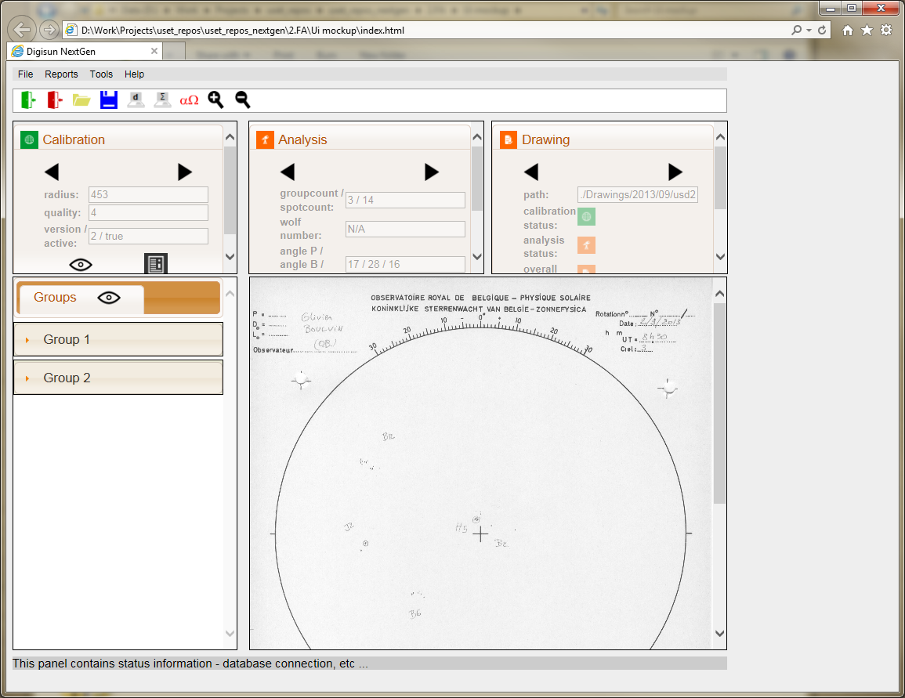  
**Figure 4: UI mockup screenshot**

|  |
| --- |
| **Note:** This screenshot is from a mockup prototype and does not resemble the final product. Its goal is to show a possible look and feel. |

There are several things to note before explaining the different sections of the screenshot.

1. This is just one page, there will be other pages as well, but this prototype is only for the purpose of showing a look and feel. Some of the options or buttons might not even make sense.
2. There is a lot of information on one screen. Too much for any user to handle in an adequate manner. Much of it can be intelligently hidden/shown, but the culprit here is the main drawing (that takes up a lot of space), but also the fact that a large part is taken up by the browser itself. The mere fact that the application is web-based has implications.  
   One of those implications is that you can develop against certain screen resolutions (the mockup currently has one fixed width of 960 pixels) or you can try to dynamically adapt the layout depending on the resolution, but both methods will require a significant development time in order for it to work properly (on all screens and all browsers). That is outside the scope of the mockup.
3. The choice of using a web-based tool has some implications on the design and usage of the tool. The most notable is sending data up and down the wire to update information on the screen. It is harder to react to keyboard interactions, …
4. The look and feel can still be tailored more towards development. Functionality like menu options and buttons are an example and do not resemble real actions.
5. The mockup prototype can be tested, but is not a working product. It should also not evolve towards a working product.
6. Note that user can close browsers, use the back/forward buttons, favorites, … which is to be taken in account when designing other pages and the interaction between them. (in the final product)

The menu bar

 **Figure 5 : The menu bar**

This section works like a classic windows menu, with drop down menus allowing a user to select an action.

The icon bar

 **Figure 6 : The icon bar**

This section works like a classic windows taskbar (not a ribbon). It is a shortcut for the most-used menu based actions.

The control section

This section gives the user an overview of the progress, the metadata on the drawing, etc… It consists of three subsections.

Calibration section

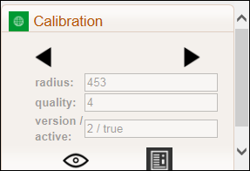 **Figure 7 : Control section - Calibration**

This section is a dropdown in order to avoid making the page to « crowded » with information. It contains information on the **calibration** of the drawing. An icon shows the calibration status, even if the panel is collapsed. The eye icon is a button, allowing to enable(D:\Work\Projects\uset_repos\uset_repos_nextgen\2.FA\Ui mockup\Styles\images\icons\Eye_24.png) / disable(D:\Work\Projects\uset_repos\uset_repos_nextgen\2.FA\Ui mockup\Styles\images\icons\Eye_disabled_24.png) the visualization for the calibration. This visualization would be : The center point, the circle (center point + radius) and the indication for the North. The edit button (  ) shows a popup with more information and allows a user to edit information.

Analysis section

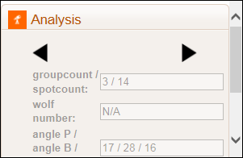 **Figure 8 : Control section - Analysis**

This section is a dropdown in order to avoid making the page to « crowded » with information. It contains information on the **analysis** of the drawing. An icon shows the analysis status, even if the panel is collapsed. The edit button (  ) shows a popup with more information and allows a user to edit information.

Drawing section

**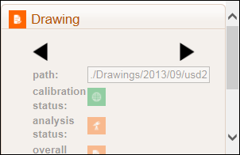** **Figure 9 : Control section - Drawing**

This section is a dropdown in order to avoid making the page to « crowded » with information. It contains information on the **metadata** of the drawing. An icon shows the drawing (overall) status, even if the panel is collapsed. The edit button (  ) shows a popup with more information and allows a user to edit information.

The working section

This section will be the main focus of the user. It consists of two subsection containing a list of groups and the drawing. Clicking on a group « header » expands/collapses the information.

Groups section

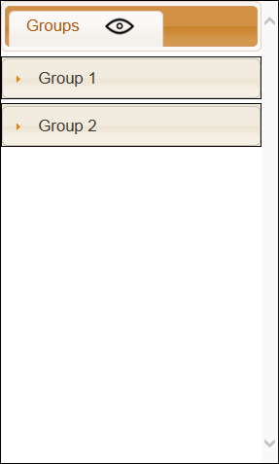 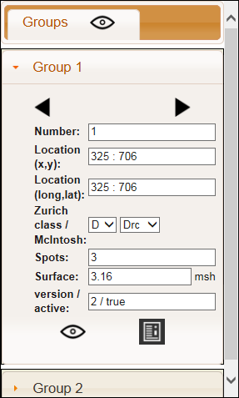

**Figure 10: Working section - groups**

The groups section contains all information by group. An eye button allows the user to enable(D:\Work\Projects\uset_repos\uset_repos_nextgen\2.FA\Ui mockup\Styles\images\icons\Eye_24.png) / disable(D:\Work\Projects\uset_repos\uset_repos_nextgen\2.FA\Ui mockup\Styles\images\icons\Eye_disabled_24.png) the visualization for that group. (location, dipole, …) The eye button on top allows a user to enable(D:\Work\Projects\uset_repos\uset_repos_nextgen\2.FA\Ui mockup\Styles\images\icons\Eye_24.png) / disable(D:\Work\Projects\uset_repos\uset_repos_nextgen\2.FA\Ui mockup\Styles\images\icons\Eye_disabled_24.png) the visualization for all groups. The edit button (  ) shows a popup with more information and allows a user to edit information.

Image section

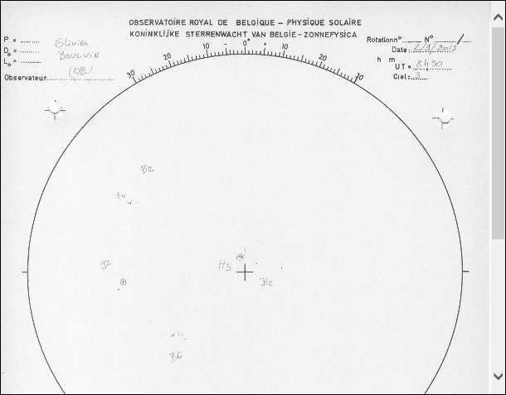

**Figure 11: Working section - image**

This section shows the drawing. The final product should allow image manipulation and drawing of overlay information (group location, dipole, calibration information, …)

Possible overlays on the drawing are:

* Sunspot group
  + Location
  + Surface polygon
  + Surface cut overlay  
    For the last two, the user could get a popup with a list of groups with radiobuttons to select for each group if they want the polygon indication or the cut overlay.
* Dipole indication
* Small/large grid
* Circle, centerpoint and north.

The status bar



The status bar at the bottom allows for some additional information like Copywrite, database connection information, etc… Alternatively this could be added to a dialog on the about popup in the help menu.

Configuration

In the current Digisun following parameters are set:

|  |  |  |
| --- | --- | --- |
| Key | Value | Description |
| drawingtype | USET | Type of drawing |
| drawingpath | N: | Contains the path to the drawing repository. |
| drawingtemppath | drwtemp | Contains the path to a temporary working directory. |
| webserver |  |  |
| leroypath | Reports/Leroy | Path used for leroy reports. |
| bulkscanlist | bulkscan.lst | Name of the file that contains the list for the bulkscan. |
| cannytresholdintensity | 80 | Treshold value for the solar edge detection. |
| accumulatortreshold | 220 | Treshold value for the solar edge detection. |
| resolution | 5.0 | Resolution value for the solar edge detection |
| minimumdistance | 500.0 | the minimum distance between the centers of the different detected circles. |
| minimumradius | 500 | The minimum radius of the detected circels |
| maximumradius | 0 | The maximum radius of the detected circles (0 = infinity) |
| contrastfixtreshold | 225 | The treshold of each RGB value that flips the pixel to black or white. |
| solardiameter | 1392684000 | The solar radius in meters. |
| scandpi | 150 | The DPI of the scan. |
| scanhorizontallines | 1170 |  |
| scanhorizontal\_a3 | 297 |  |
| scanverticallines | 1700 |  |
| scanvertical\_a3 | 420 |  |
| scanformat | JPG | Can be any of the following: BMP, TIFF, GIF, PNG, JPG. |

For Digisun NextGen the following settings should be changed.

|  |  |  |
| --- | --- | --- |
| Key | Value | Description |
| scandpi | 300 | The DPI of the scan. |
| scanformat | PNG | Can be any of the following: BMP, TIFF, GIF, PNG, JPG. |

Risks / Issues

|  |  |  |
| --- | --- | --- |
| id | Risk/Issue | Solution (proposal) |
| 1 | SQL injection | Use parametrized queries, use data validation. |
| 2 | Unauthorized usage. | Firewalls, logins, … |
| 3 | Changing from one version to the other | Run both versions in parallel for a while to make sure nothing breaks and results come out the same. |

Security

Security is fairly simple by using a login. If no valid login has been given the user is allowed to read the data, but no changes are to be made. With a valid login, the user can edit any information. Changed information is saved with history.

There is no concept of roles defined, allowing some users to have more rights than others.

User logins consist of a username/password combination. Passwords are saved in the database as a salted hash value. (<https://en.wikipedia.org/wiki/Salt_(cryptography)> )

Performance

To increase performance perception for the user, many of the actions will take place on the client side. Client-server traffic will be limited to avoid unnecessarily sending data up and down the wire.

Constraints and limitations

Realistically only a limited set of browsers will be supported:

* IE 10 and 11 and the new Edge browser
* Chrome Version 44 and above
* Firefox version 37 and above
* Safari version 8.0 and above

Mobile devices will not be supported.

Appendix

Appendix A: Q & A

|  |  |  |  |
| --- | --- | --- | --- |
| Id | Date | Question | Answer |
| 001 | 15/04/2015 | What should the project name be? | Digisun NextGen is OK for now. |
| 002 | 10/06/2015 | Should there be support for mobile devices and to what extent? | No request for this has been made. |
| 003 | 10/06/2015 | The “observer” context seems somewhat ackward (the late login, etc…). Wouldn’t it be better to have a login at starting digisun? | Login at startup is desired. |
| 004 | 10/08/2015 | Operator/Observer. Advice would be to create a person table with better and cleaner information and link the observer/operator to that table. | Create the person table |
| 005 | 28/08/2015 | Can a user (or anyone) use the tool from outside ROB ? | Mail Olivier L: 31/08/2015 This is a tough one in my opinion, because it raises a lot of questions. Will this tool be available for all our observers (others stations than USET) for example? In that case, will we be offering this service and storing all the data ourselves? Or will the product be offered without database infrastructure, like a Almost Ready to Work product that you have to care for your own database, etc..? |
| 006 |  | “For USET77 drawing types this is the south and the north of the solar disc.” How is the center determined in that case? |  |
|  |  |  |  |

Appendix B: Trains of thought

This appendix gives some brainstorming ideas which might become useful in the future.

* Should images from scanned drawings and images from the camera be used in a mixed way in the future (overlays, switching between images, etc …)
* Can SPoCA be re-used for image analysis ?

Appendix C: Types of drawings

Drawings have different sets of parameters to take into account. Some properties are different even between the same types of drawings like eg. The pixelformat.

Type: USET

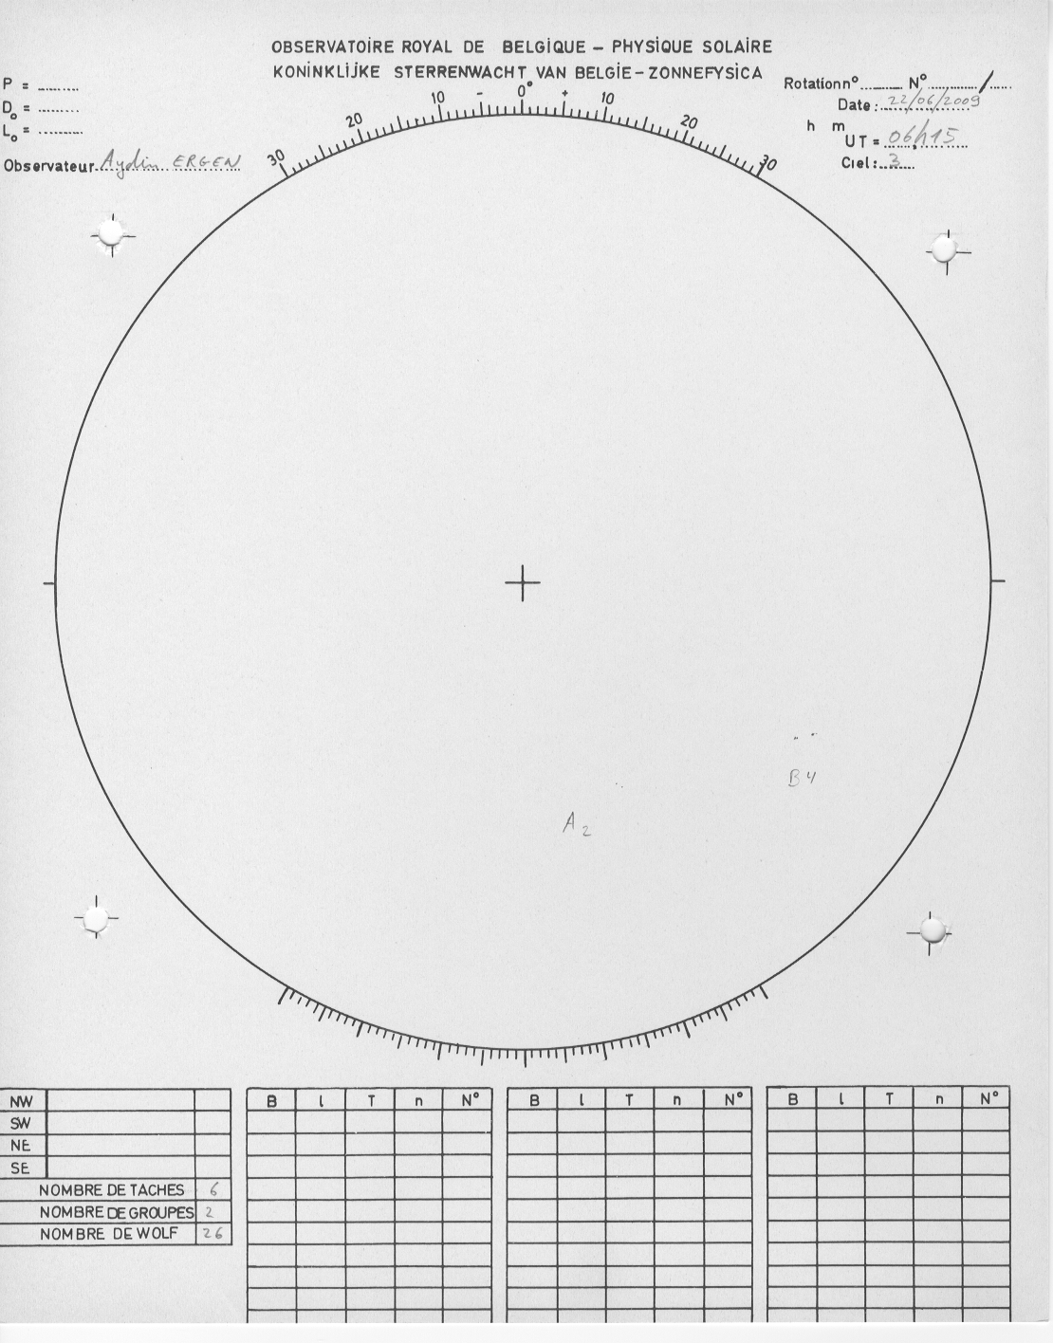

Figure C1: Drawing type: USET

This type of drawing has a size of : width: 1110 x height: 1416.

It has a small cross in the center and therefore the “center click“ is used for calibration (see workflows). This template is still in use today.

Type: USET41

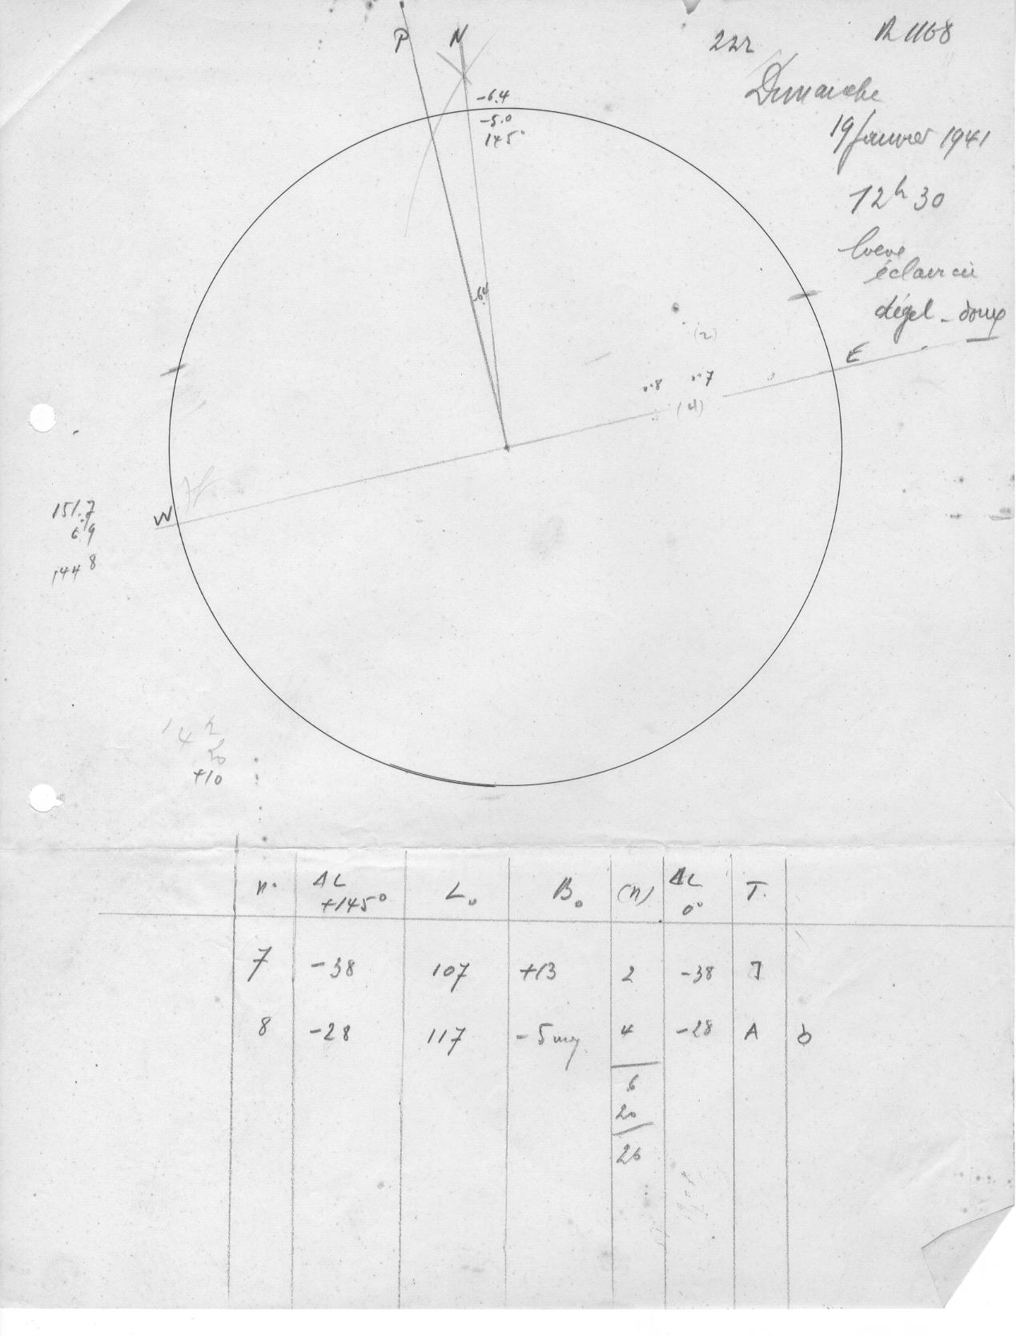

Figure C2: Drawing type: USET41

This type of drawing has a size of: width: 1269 x height: 1669.

It has a center indication and therefore the “center click“ is used for calibration (see workflows). This template is no more in use today.

Type: USET77

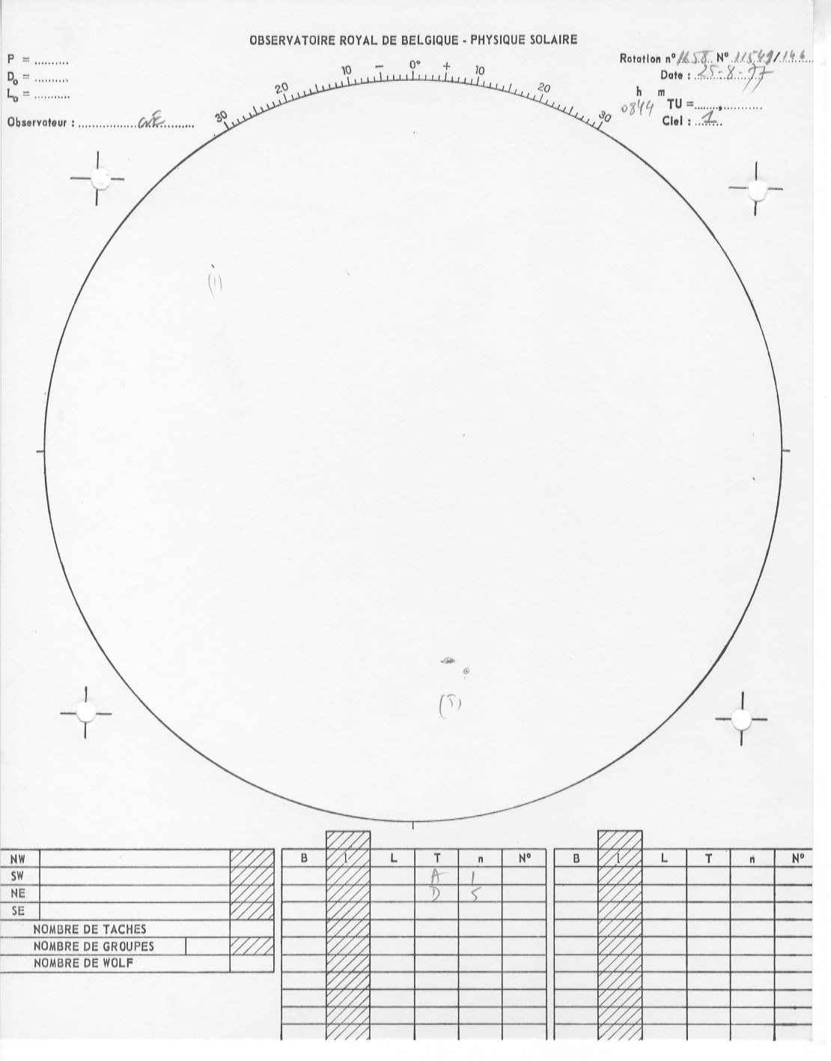

Figure C3: Drawing type: USET77

This type of drawing has a size of: width: 1110 x height: 1416.

It has no center indication and therefore the “south click“ is used for calibration (see workflows). This template is no more in use today.